From 50% to 90%: Optimizing International Delivery Success
I am looking at the lifecycle of approximately 8,000 international shipments. Columns A through L are categorical shipping label data. Columns M forward are shipping implementation data. I will evaluate the data to see how well the processes work and what can be improved.
Delivered package data is cross reference reliable. Undelivered package data is unreliable when cross referencing the various fields. So, I concentrated on delivered data first. Within delivered data, my biggest question was why are packages delivered late?
I focused on three questions: (1) Are delays systemic or localized? (2) What operational factors (handoffs, customs, service level, etc.) drive lateness? (3) Are the issue execution or unrealistic delivery estimates?
Excel was used for data cleansing. I formatted both the estimated and actual delivery timestamps by normalizing all timestamps to a single time zone (UTC). I noticed that filtering the Current Status column on Delivered had the actual delivery timestamp filled in, so it is reliable. I used the Delivered Status for most of my computations. I subtracted the timestamps to see which packages were early or late compared to the estimated delivery timestamp. I loaded it into Python and did the calculations and analysis below.
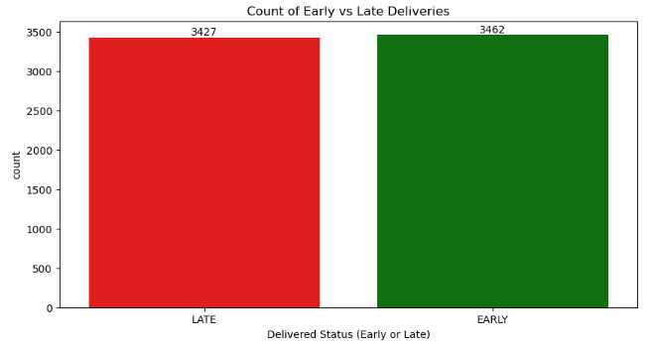
This bar chart shows that a package is just about equally (50%) likely to be early or late. I will look further into the Late deliveries because that is more of a concern. I would like to see where we can improve.
I created multiple graphs from shipping label columns A through L looking at the carrier, service level, origin to destination country, customs, weight, etc. There was no significant predictor. Late rates remain consistently within a narrow 40–45% band across carriers, service levels, and shipment characteristics, suggesting the issue is systemic rather than driven by any single operational factor. Those graphs are included as a separate attachment.
Contrary to expectation, delays are not driven by specific factors such as lanes, carriers, or shipment characteristics.
The primary issue is systematic underestimation of delivery times. The current algorithm lacks the necessary 'padding' required for international logistics, leading to consistent over-promising delivery times which create negative customer impacts. My analysis of the actual lead times provides the data needed to bridge this gap by creating scheduled deliveries.
Achieving a 90% on-time delivery rate requires aligning estimated delivery times with actual performance.
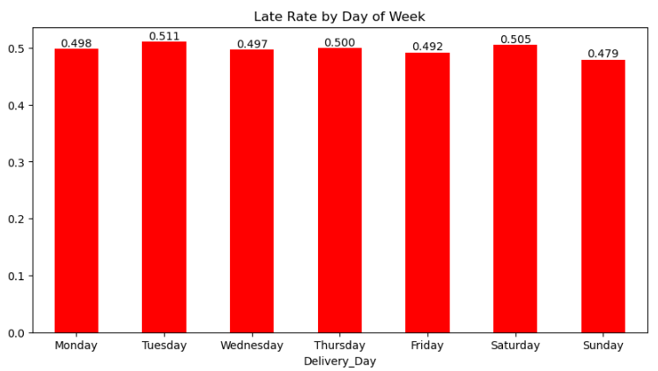
I analyzed lateness across multiple categories, using Day of the Week as the primary example. To ensure these findings weren't isolated, I validated the results against the Customs category. Both analyses consistently identified an 18–19-hour delay at the 90th percentile, confirming that this is a systemic bottleneck across all shipment types.
Grouping the actual delivery timestamp by day of the week and finding the average late deliveries for each day produced in the bar chart above. All the days of the week are very close. We need to find how long to push out the estimated delivery timestamp to reach 90% accuracy.
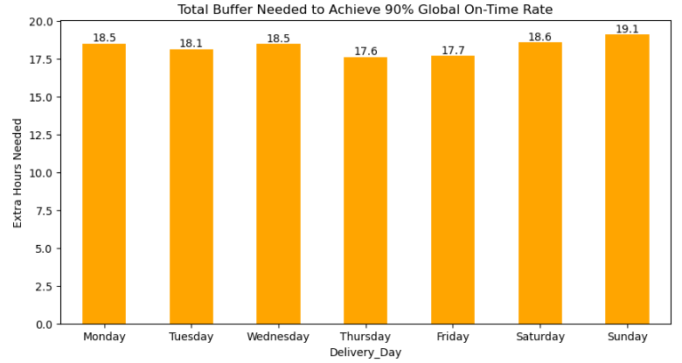
To get to the 90th percentile Early for all deliveries, we add 18 to 19 hours to our delivery estimates. This adjustment would bring approximately 90% of deliveries to the promised window. We are using the 90th percentile to cover significant delays and create a safety net that captures almost all scenarios.
Sunday presents a unique 'Severity vs. Frequency' paradox: while it has the lowest frequency of late deliveries, it suffers from the highest severity of delay (19.1 hours) when a failure occurs. This means that Sunday deliveries are late slightly less often. When they are late, they tend to be late by a much longer margin than weekday packages.
Making these adjustments to the estimated delivery algorithm can prevent over-promising on some days and under-promising on others. If we add these specific hours to our estimates, we can expect to drop the late rate from 50% down to 10%.
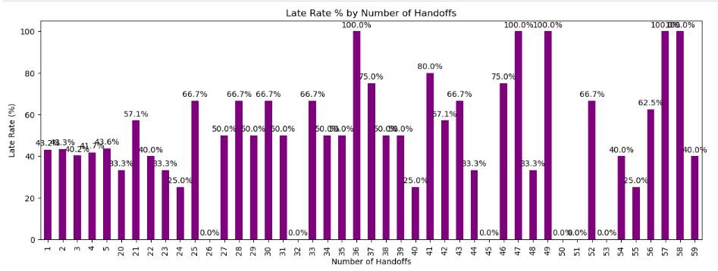
For fine tuning of late deliveries, I looked at deliveries with multiple handoffs. Does the number of handoffs affect the late rate? Grouping by handoff count and calculating the average late rate produced the graph above. Up to five handoffs look stable and predictable (40-45%). More than 20 handoffs experience extreme volatility and significantly higher failure rates, often hitting 100% late. Each additional handoff after that increases the probability of late delivery. Thus, we should designate 20 handoffs as the maximum "safe" operational limit. Beyond this point, the system becomes highly unstable. This is fine tuning because this systemic change only affects about 2% of all late deliveries, making this a secondary optimization rather than a primary driver.
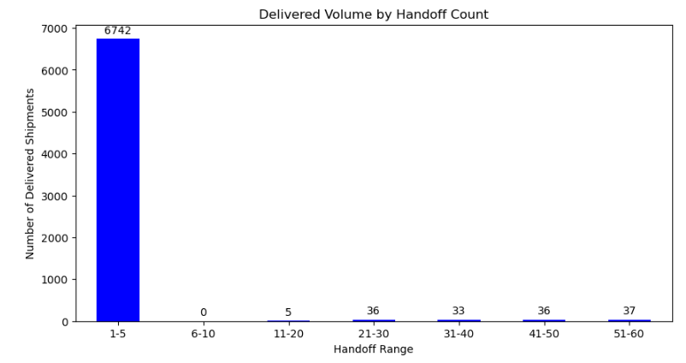
Since there are so many spikes after the 20 handoffs, I wanted to see how often there is a large handoff. While the graph shows that most shipments fortunately fall within the 1-5 handoff range, a low sample size of high-handoff outliers suggests a need to cap 'touches' at 20 to maintain the 40% baseline.
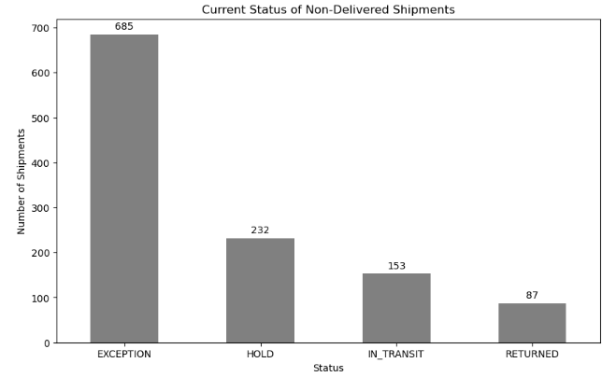
The remaining 1,157 Non-Delivered shipments (14%) were excluded from the variance analysis due to missing timestamps. The primary Non-Delivered categories are Exception (8.5%), Hold (3%), In-Transit (2%), and Returned (.5%).
A preliminary review suggests the Exception category warrants further investigation. Due to the unstructured, handwritten, and multilingual nature of the Exception Descriptions, a difficult data cleansing secondary translation would be required to identify specific root causes for these delivery failures. Exception data is unstructured and not fully analyzed.
The hold and returned categories have similar data cleansing issues about variations of their exception codes. The in-transit category is just waiting for further processing.
The lifecycle of international shipping is a complex and thoughtful process. I recommend increasing estimated delivery times by 18 hours to align with actual performance to achieve a 90% confidence level for on-time arrivals. This directly improves customer expectation accuracy and reduces perceived service failures. Additionally, I recommend flagging shipments exceeding 20 handoffs for intervention. Audit high-handoff outliers to identify preventable routing inefficiencies. Implementing these data-driven and highly actionable adjustments will immediately stabilize customer expectations and provide the operational transparency needed to scale our international delivery performance.

